# DevOps Board

# 

1. **Introduction**

For any software project, we need three things.

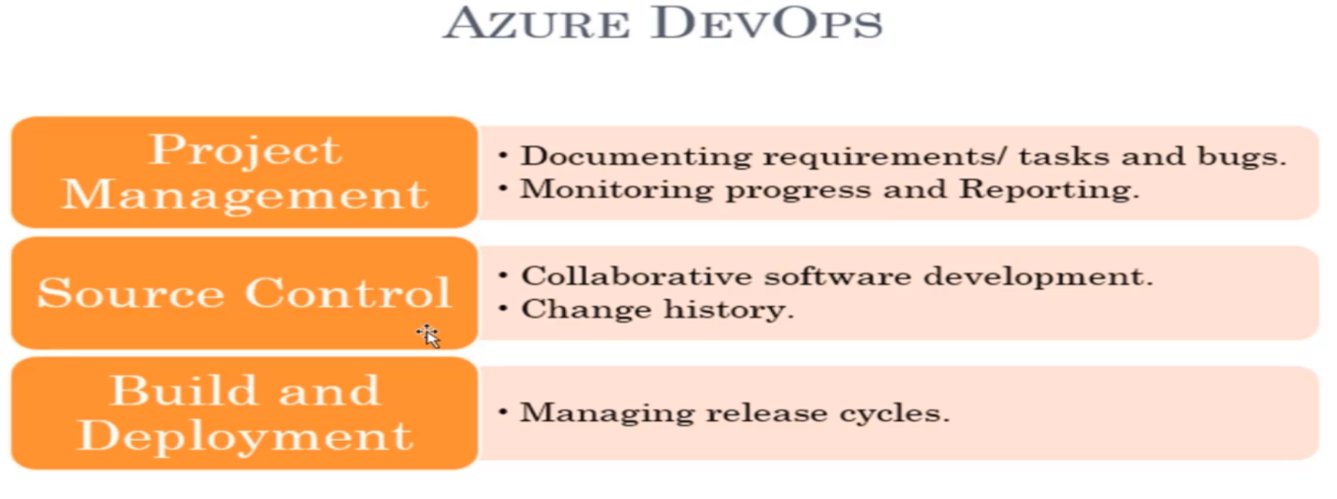

* Every software project needs a project management to a place where we can gather the requirements, break it up into various tasks and assign people and monitor those tasks. We currently using JIRA for this kind of project management.
* Every software project needs a source control or version control tool. The source control tool will maintain who made what changes and maintain the history of the code changes.
* So every software project needs a built in deployment tool.

Azure DevOps can do all these three.

1. **Project Planning: Agile & SCRUM Lifecycle**

Scrum means - multiple releases and sprints. So, we need to set up these releases and sprints.

A sprint is a short duration milestone. So, every two weeks you may have a sprint and for every four sprints, you may have release.

Go to Project Settings -> Project Configuration – Here you can add your own iterations

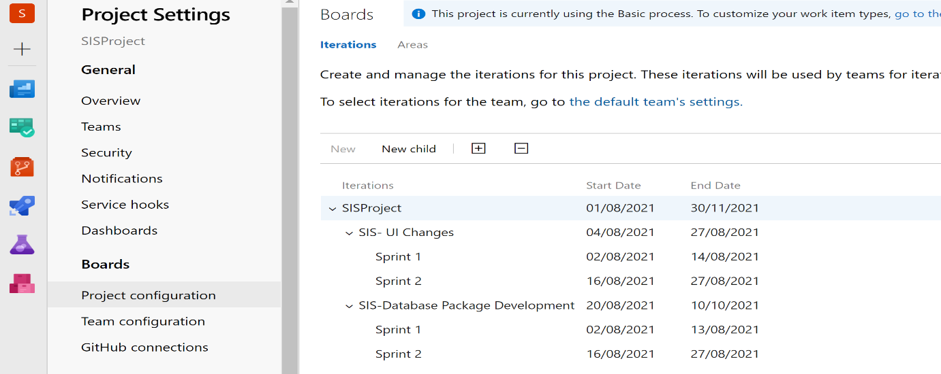

**Area:** when you gather requirements and you want to store it somewhere in repository with logical segregation. Usually every team that are the part of project will have their own area.

1. **EPIC:**

Epic is a requirement that takes multiple releases to complete. That means it takes many months to complete.

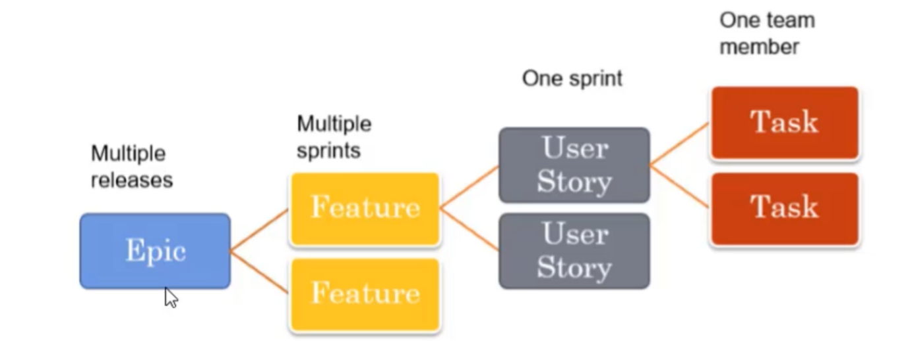

Create an epic and then we will split up an epic into multiple features and then we'll split up a feature to multiple user stories, and then we will split up a user story into multiple tasks.

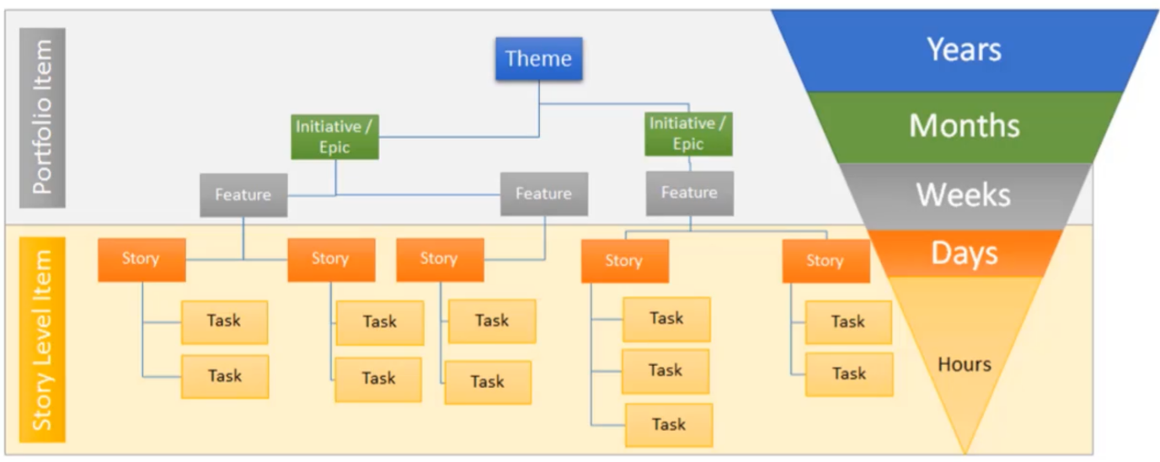

Epic is usually not done by one person, but usually one person in charge of the epic, usually a senior manager or a team leader or the senior most business analyst.

1. **Feature:**

Once you created Epic -> Go to BackLogs -> Select Epic (From Right Drop down) -> Create Feature

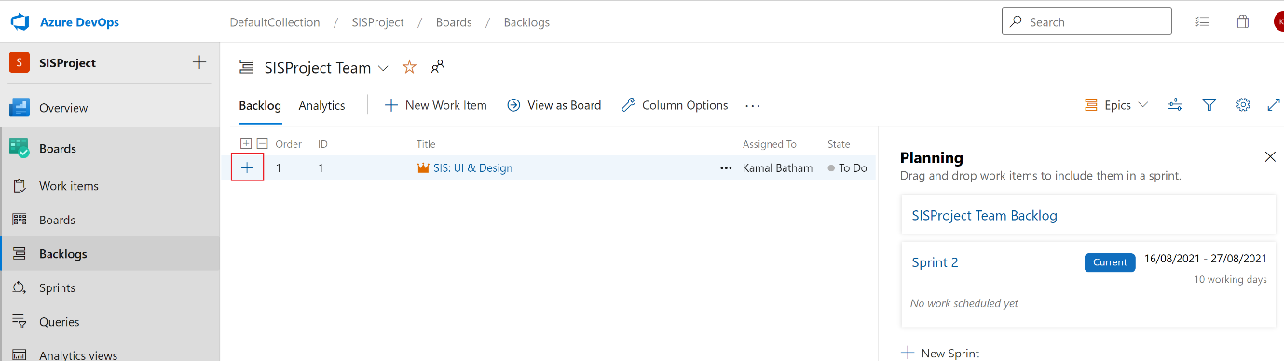

**Note:** If Project Created in **Scrum** process, then only it will allow to create feature. If It is **Basic** then you can only add New Issue

When we create our Azure DevOps project in Agile or Scrum process -> Then we can create Epic's, be able to create features, user stories, stars and even issues. You can also go ahead and create your bugs as well.

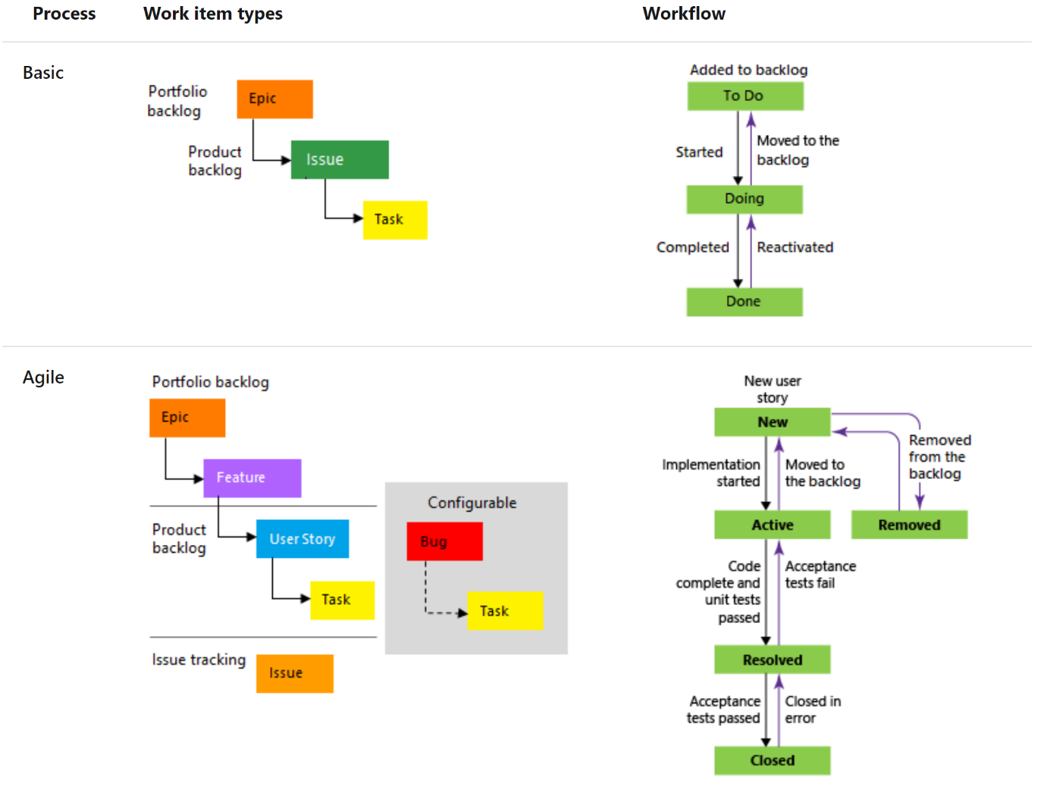

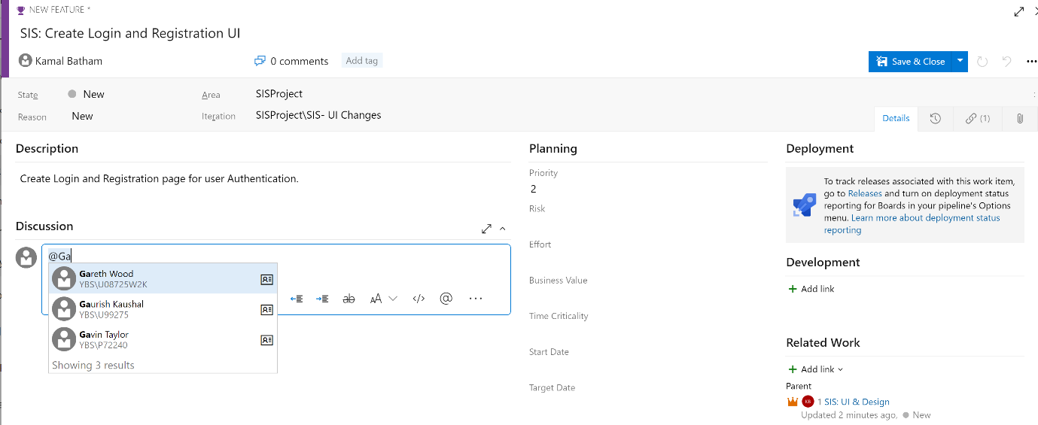

This # sign is used to specify that this feature or an epic is related to another feature or an epic. We will specify these things if you feel like some other feature is related to this particular feature, then we can specify those features right here using the number of the exclamation point.

With this -> the team who are working on other Epic or Feature get aware of that some other team working on same functionality that involve into their feature task.

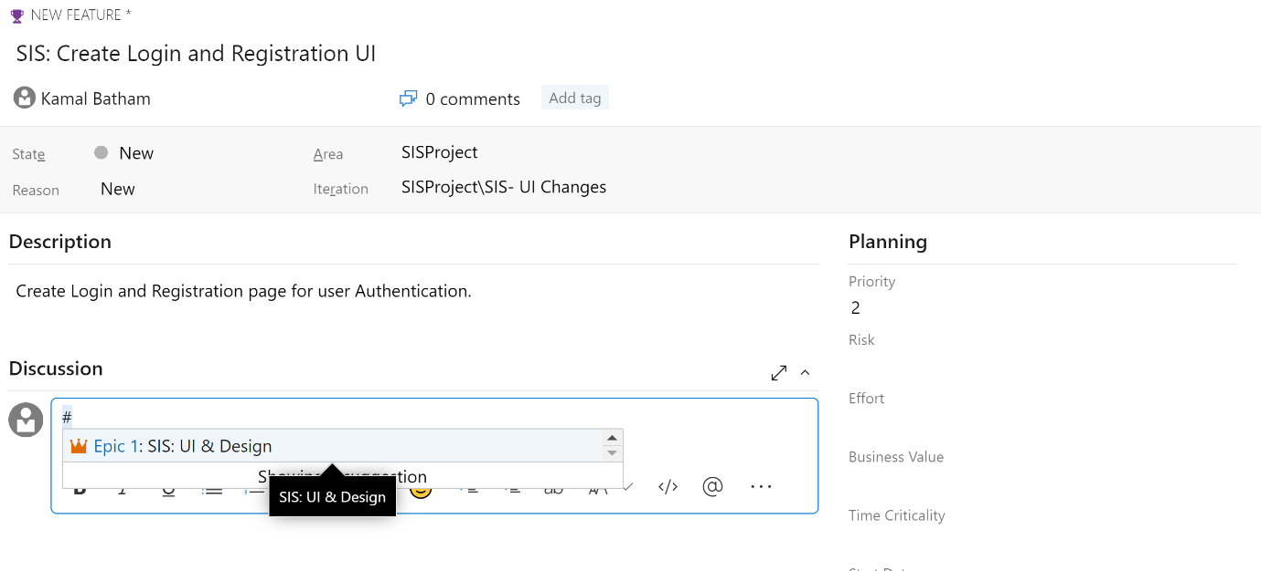

If we want to see more column like (Created By) -> Click on Column Options - > Add column

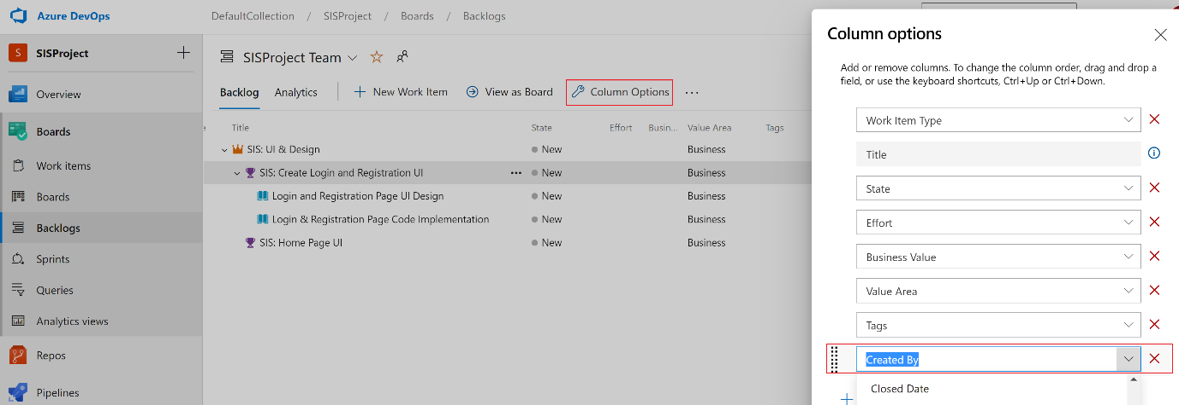

1. **Task:**

Under User Story -> We can further add the task -> Tasks are usually measured in hours.

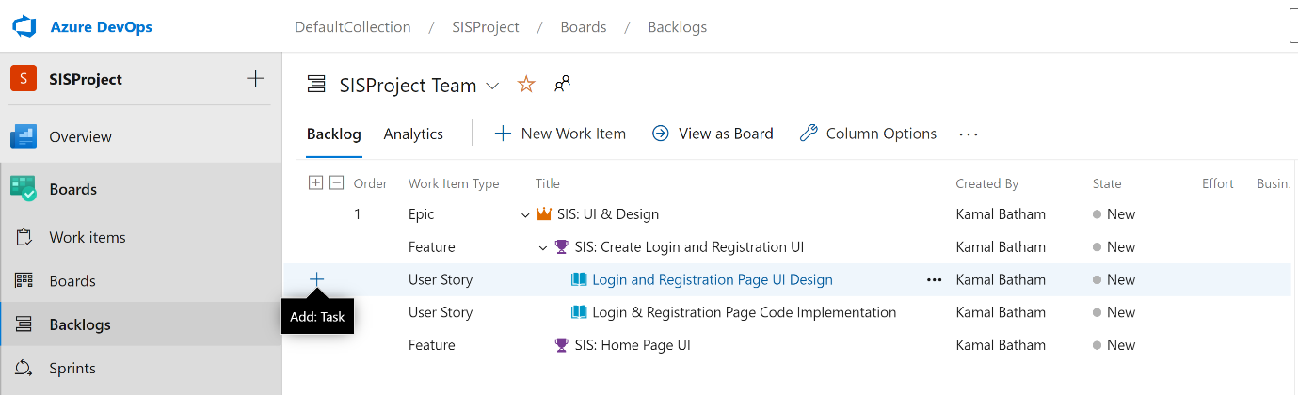

Two tasks created in the User Story

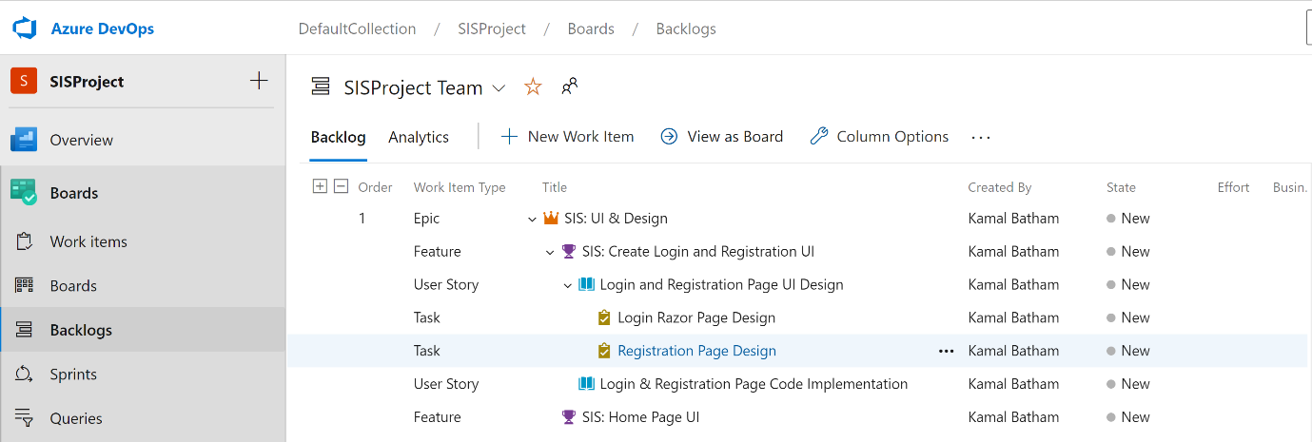

1. **Task boards and other features**

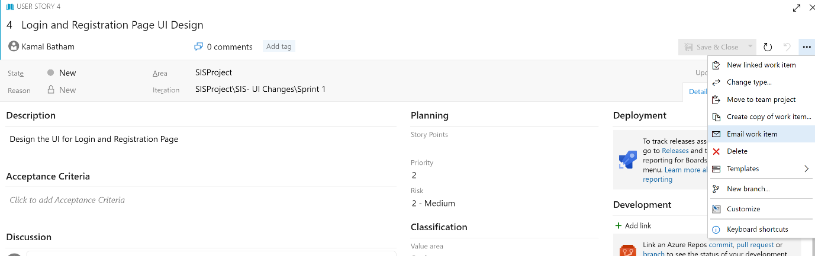

1. **Sprint:**

Click on Sprint -> You can see the Taskboard, to see that as a Kanban board, but this is much more easier to see.

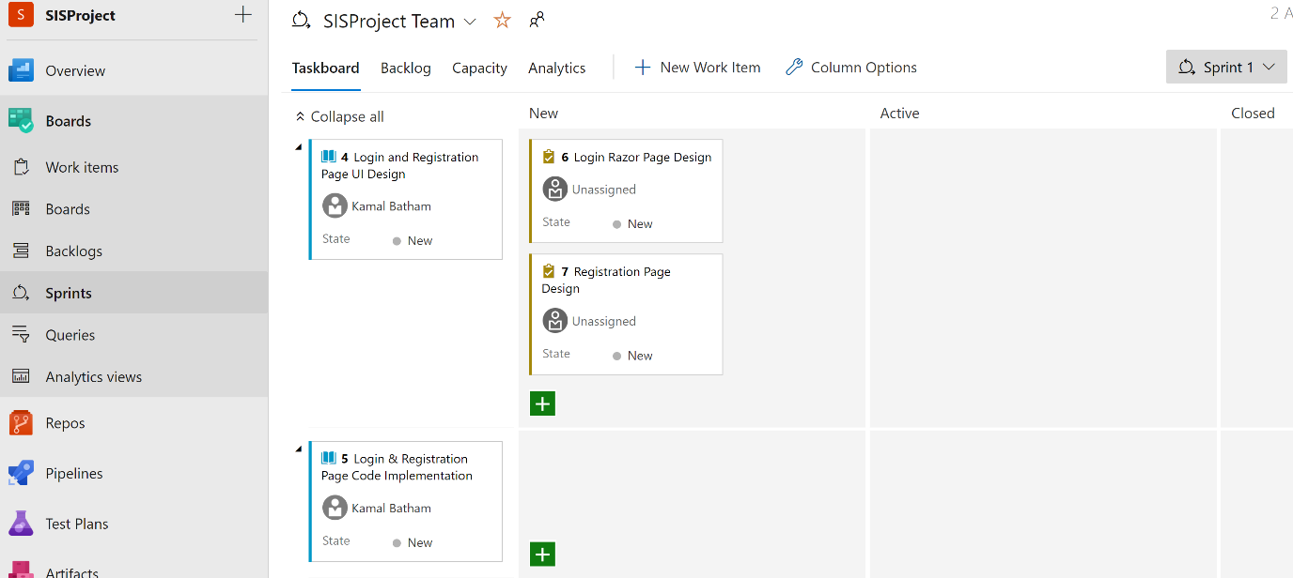

The backlog -> We'll show you all the user stories and the tasks that are available in this current sprint.

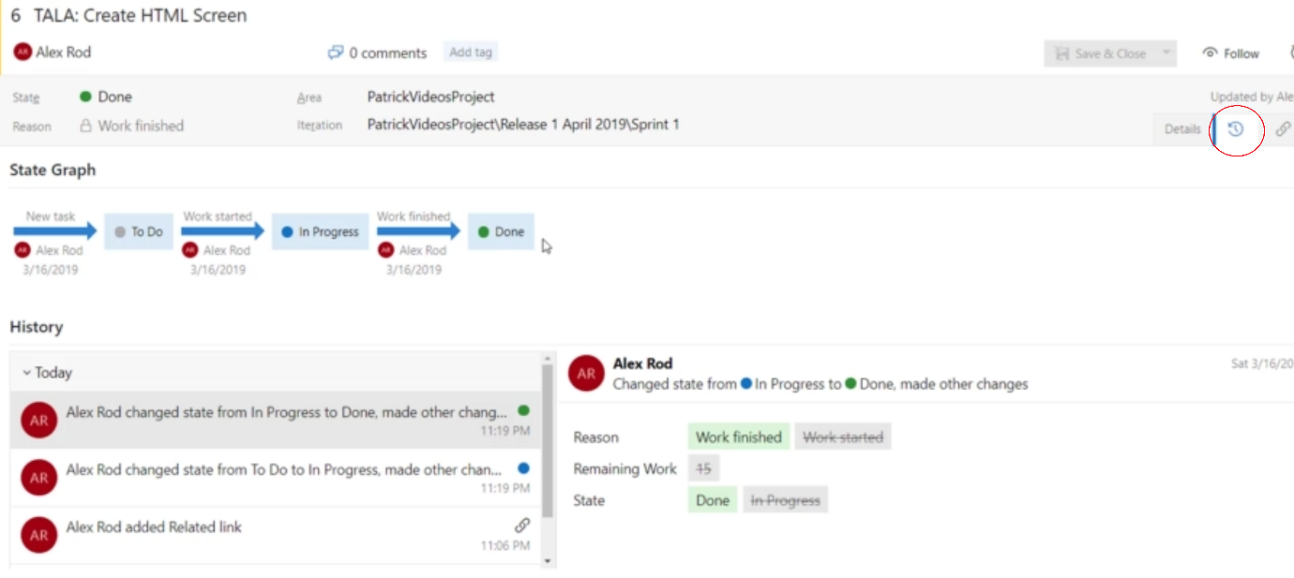

1. **Customize the Board Column:**

If we need to customize the Board columns -> Click on right RED highlighted area -> Click Column -> Add New Column (On Hold) -> If need rearrange it over here

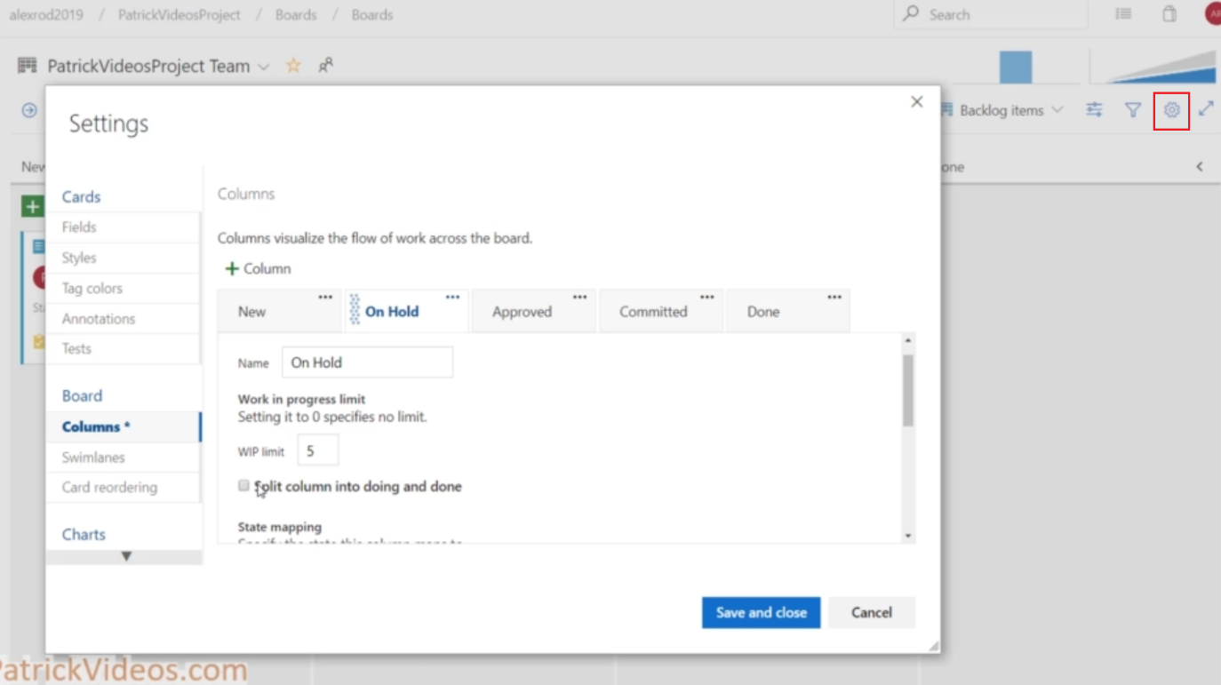

1. **Queries:**

Click on Queries -> All -> it will show you all workitem and queries

Click on Assigned to me -> We can see all task, and feature assigned

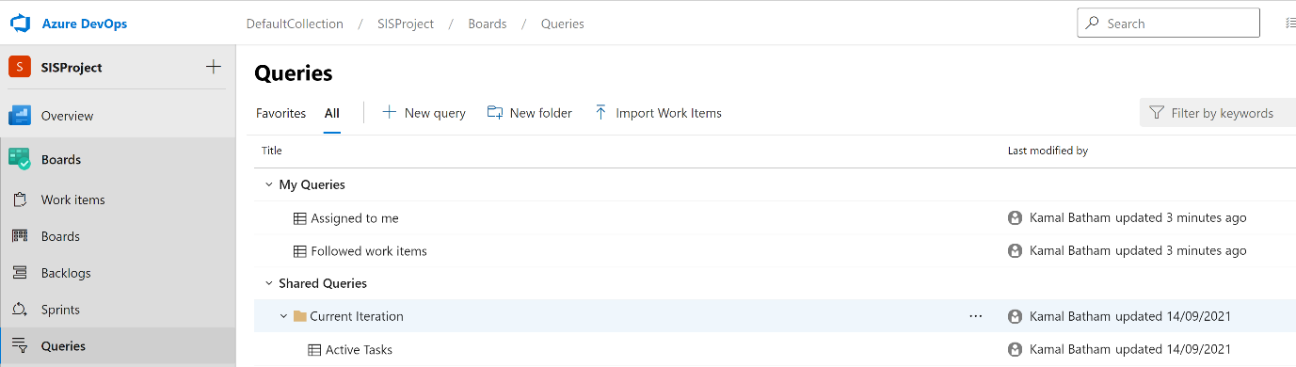

**Click on Queries -> New Queries ->**

The advantage of using @me is that whoever runs this query, it will run against that name. Like if I run this query, it will run against my name, and if someone else runs this query, it'll run against them.

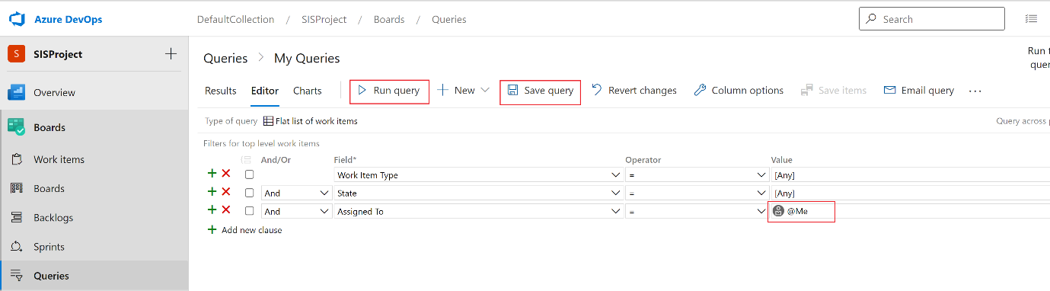

Run the Query -> To see the result

Save the Query -> To save it for future use -> We can save it as My Query or Shared Query

If I save it under my equities, only I can see this query. If I save it as shared query than anyone else can see this query and anyone else can run this query.

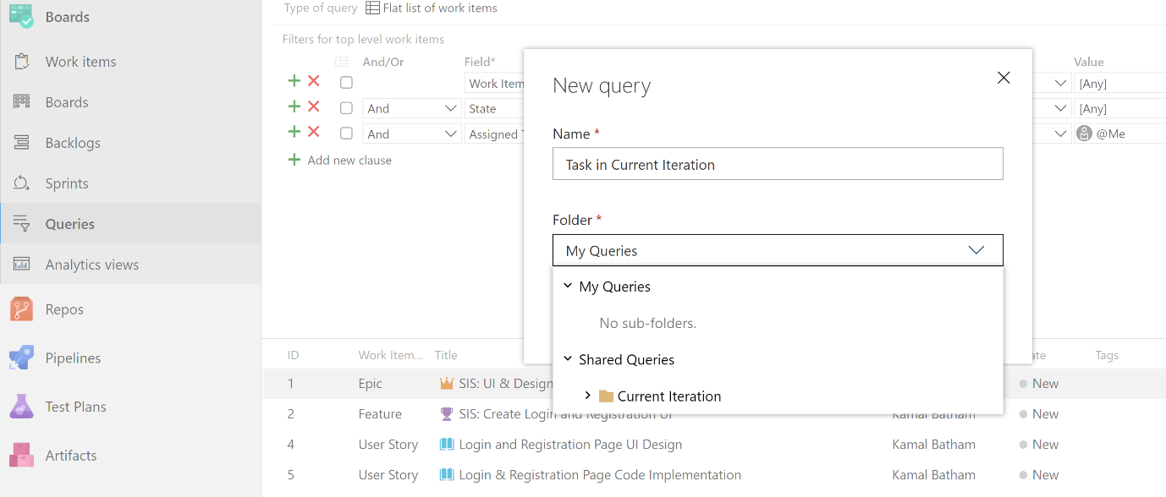

Query to see only Committed, done and To Do

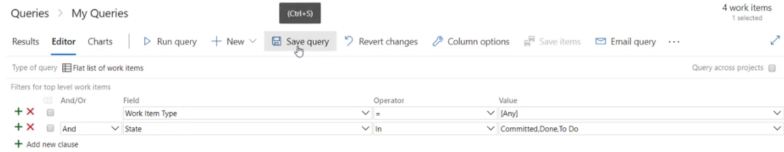

We can create the chart

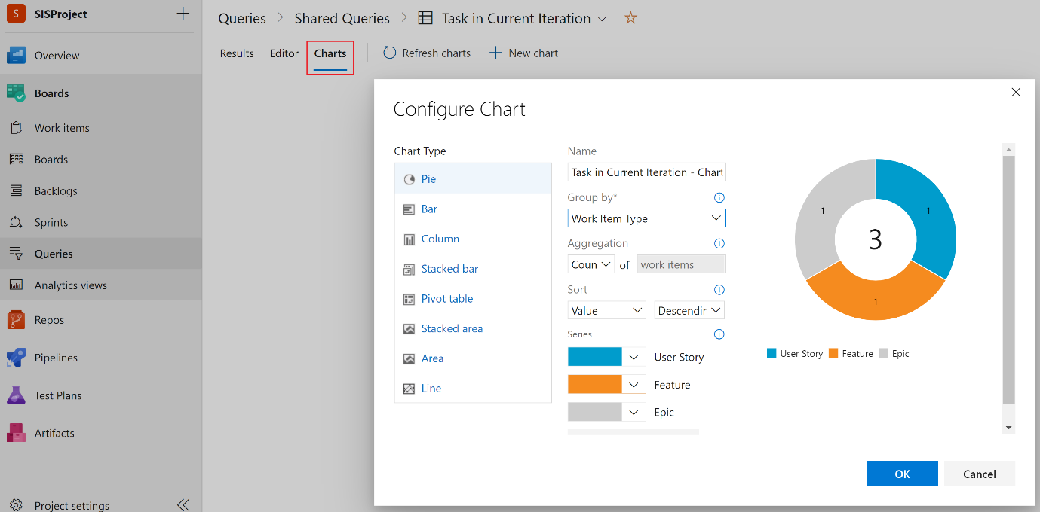

We can pin the chart into Dashboard

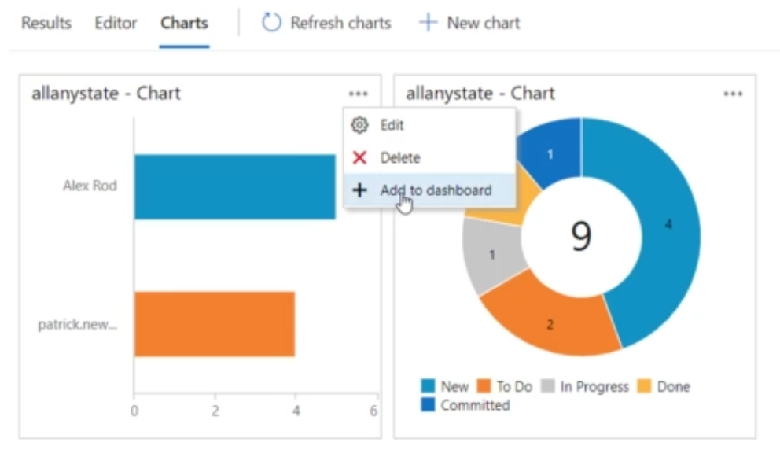

1. **Capacity**

We can assign and allocate the time for each individual work -> Also add the Day off -> and also can add team Day Off

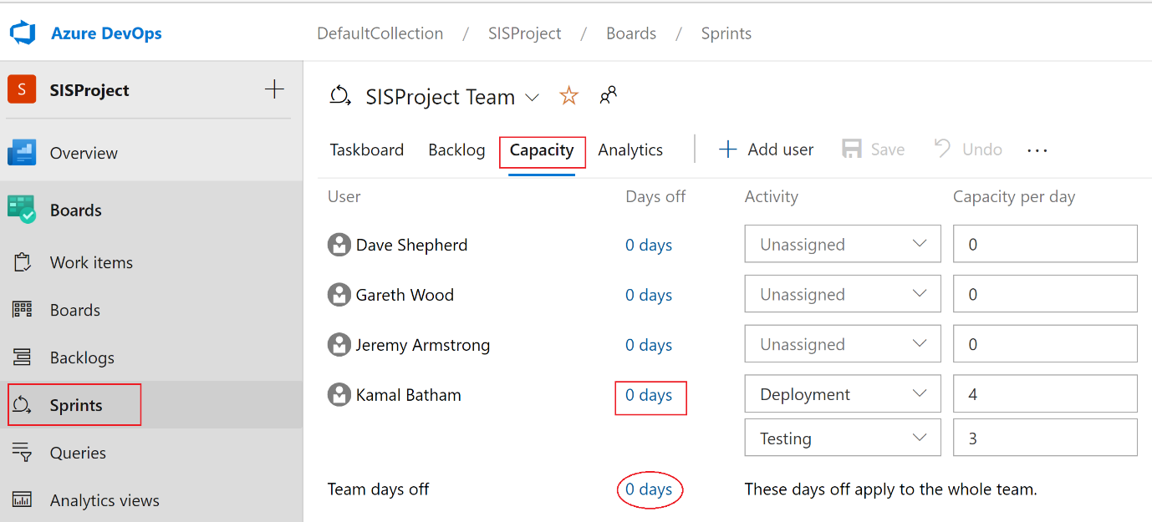

On below path -> we can see the capacity available of each individual during the sprint

